*Florida International University*

*School of Computing and Information Sciences*

Software Engineering Focus

Feature Document

User Story ID 698

**Name:** Modify Sub-user’s information

**Team Member(s):** Leandro Gonzalez,Luis Herrnsdorf

**Project:** Smart Stormwater (Smart City System) 2.0

**Product Owner(s)**: Emilio Lopez

**Mentor(s)**:

**Instructor**: Masoud Sadjadi

**User Story Name:** Modify Sub-user’s Information

* Description: As an admin, I want to be able to edit a sub-user’s information, so that I can be able to correct any false information and/or update a sub-user’s profile.

Acceptance Criteria

* The page can be accessed through the Sub-User list page via a “Modify” button
* A floating window will appear, displaying the selected user’s information
* The admin can edit the sub-user’s information
* The admin can cancel at any time, returning to the sub-users page
* Upon clicking ‘Update Profile’, the changes will be persisted to the database, the floating window will close, and the changes will be reflected in the sub-user table

**Use Case**

* Name: Modify sub-user
* Actor: Admin
* Preconditions: Admin is logged in
* Description: On the main page, the admin clicks on the ‘Users’ tab on the side panel. On the ‘Users List’ table, the admin selects a user by clicking on it. Admin clicks on the ‘Modify’ button of the selected user, a floating windows comes up displaying the selected user’s profile information. The admin can edit the selected user’s information, and then click on either ‘Cancel’ or ‘Update Profile’. The changes are persisted to the database, the floating window closes and the ‘Users List’ page reflects the changes

**Use Case Diagram**

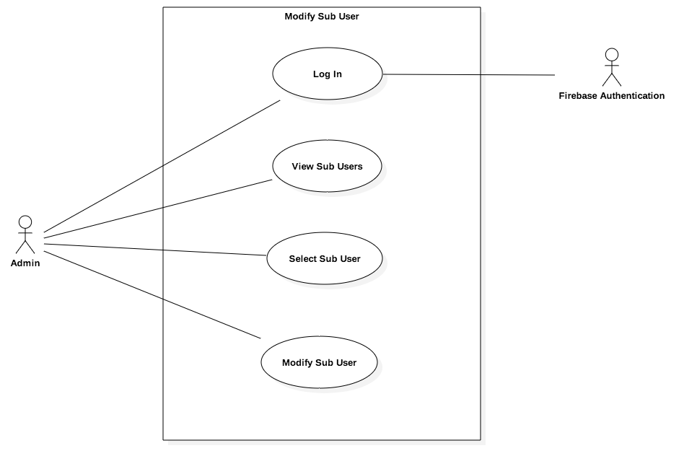

**Sequence Diagram**

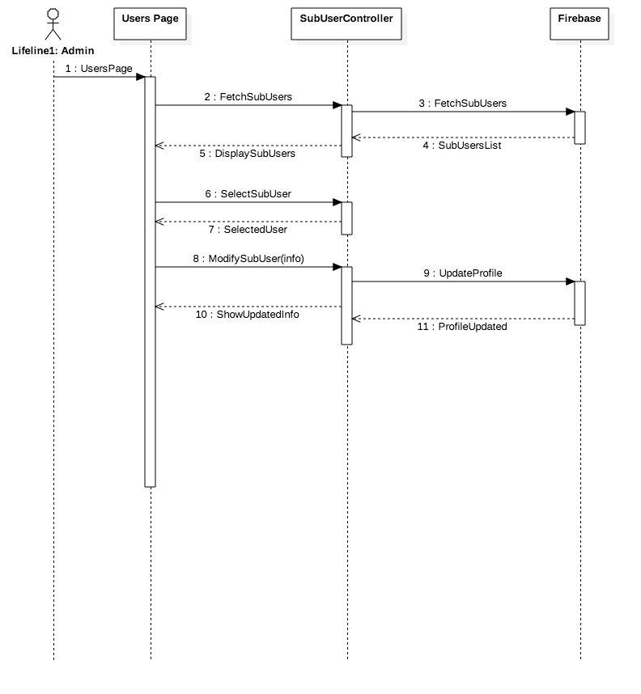

**Class Diagram**

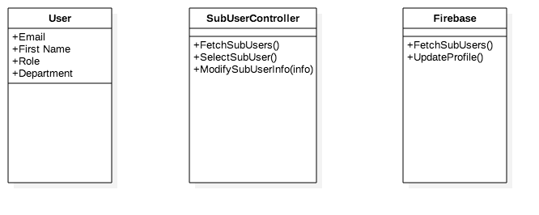

**Unit Test**

* Test case ID: ModifySubuser001
* Description/Summary of Test: Admin modifies a sub-user’s profile information
* Pre-condition: Admin is logged in, admin has sub-users
* Expected Results: Sub-user’s profile information is updated
* Actual Result: Sub-user’s profile information was updated
* Status (Fail/Pass): Pass

**Visual User Guide**

